Pokhara University

Level: Bachelor | Semester – Spring | Year : 2006
Programme: BE |  | Full Marks: 100
Course: Integrated Digital Electronics |  | Time : 3hrs.

Candidates are required to give their answers in their own words as far as practicable.
The figures in the margin indicate full marks.

Attempt all the questions.

 | - For the BJT inverter shown below draw the voltage transfer characteristics explaining and showing the values for all the necessary points. Also find both the low and high noise margins and the logic swing. Assume β_{F} = h_{fe} = 50, V_{BE(on)} = 0.65V, V_{BE(sat)} = 0.75V, V_{CE(sat)} = 0.2V.  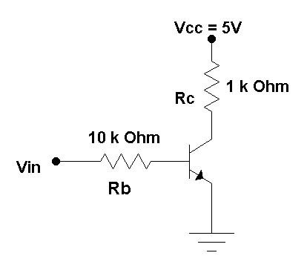  b) How does I²L offer high packing density? Show the interconnection diagram for a 3 to 8 decoder in I²L and briefly explain it. | 8  7
 | - For the DTL gate shown below, calculate the fan-out assuming that all the inputs are at logic level 1 (5V) and T2 is driven into saturation. Take V_{BE(Sat)} = 0.75V, V_{D} = 0.75V, V_{CE(Sat)} = 0.2V and at saturation I_{C} = σ h_{FE} I_{B} where σ = depth of saturation = 0.85. State all other necessary assumptions you make.  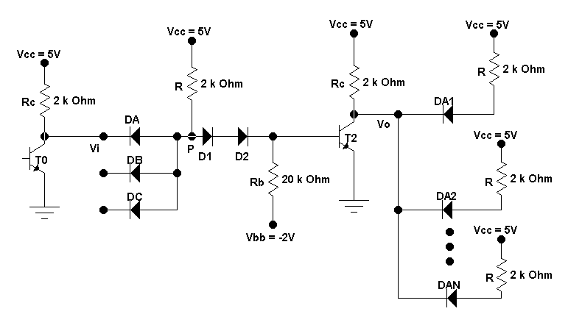 | 8
 | b) Shown below is an “On Chip” TTL Inverter Circuit. Use β_{F} = 20, and β_{R} = 0.2.  - Sketch the VTC showing values of all the breakpoints.  - Compute the fan-out with NM_{H} = NM_{L}.  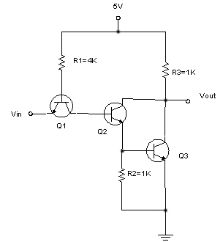 | 7
 | - Draw the circuit diagram of standard 2-input TTL NAND gate. Briefly explain input transistor action and verify its truth table.  - Discuss the various advantages and disadvantages of ECL logic family.  - Explain with diagram ECL-Gate interconnection with TTL. | 5  5  5
 | - Compare various Bipolar and MOS technologies on the basis of the design parameters fan-out, power dissipation, packing density and switching speed.  - Consider the CMOS inverter given below. Let K_{P}=K_{N}, |V_{TN}| = |V_{TP}| = 1.25 V, and V_{DD} = 5 V. Find the transition points for the p-channel and the n-channel transistors.  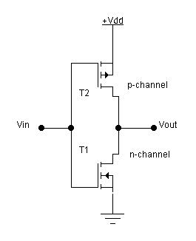 | 8  7
 | - Explain the read and write operation in static MOS RAM along with the circuit diagram.  - Draw the physical structure of the MOS transistor used in EPROM and also explain how the data is read and erased in EPROM. | 8  7
 | - Discuss the various styles of modelling used in architecture body of hardware description in VHDL.  - State the various applications of analog switches and explain the operation of a CMOS transmission gate. | 8  2+5
 | Write short notes on (Any Two):  - High Threshold Logic  - CMOS NAND Gate  - RTL Ex-OR Gate  - Feature of VHDL | 2×5

